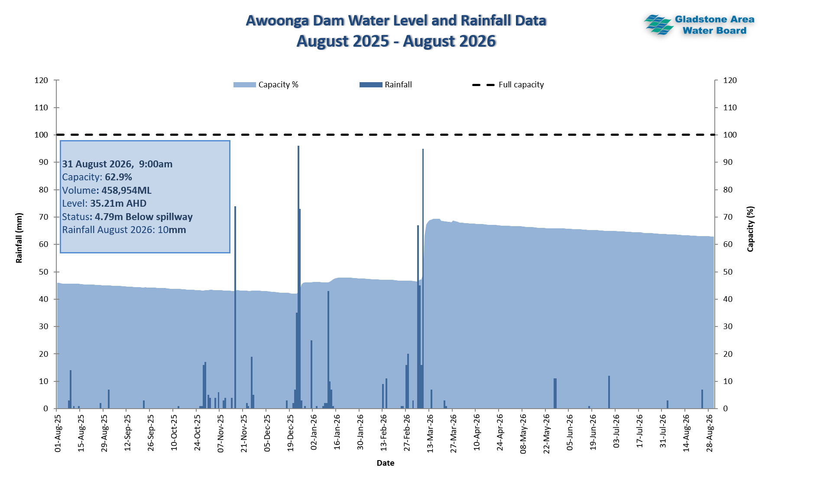

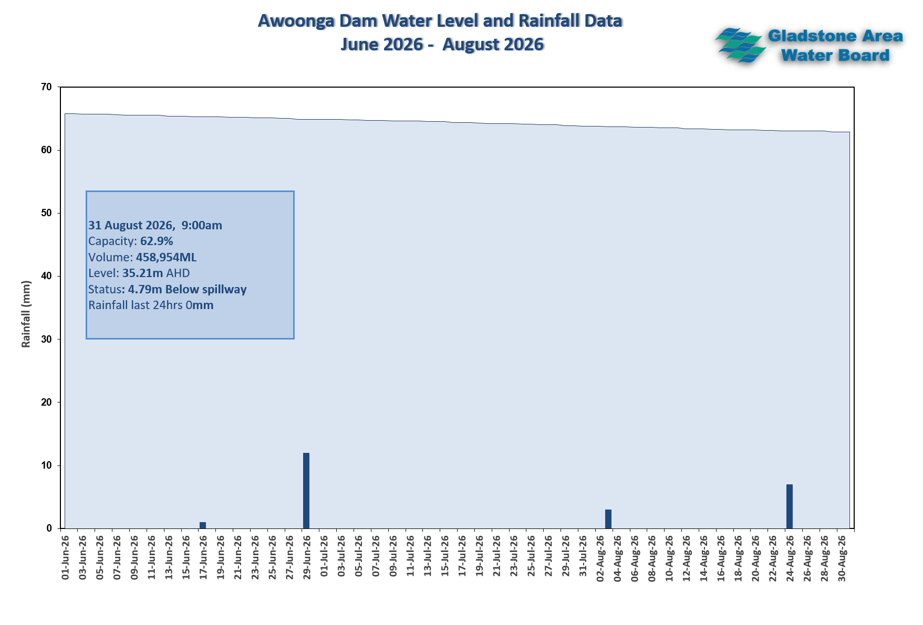
Historical Storage Levels (as at August 31)
Storage Level | Date | Level (m AHD) | Volume (ML) | Capacity (%) | Surface Area (ha)
Current Storage | 31-Aug-26 | 35.21 | 458,954 | 62.90 | 3,883
Level One Month Ago | 31-Jul-26 | 35.36 | 466,077 | 63.80 | 4,096
Level One Year Ago | 31-Aug-25 | 31.47 | 328,352 | 45.00 | 3,307
Historical reference - Lowest Level | 4-Feb-03 | 20.84 | 57,803 | 7.44 | 1,298
Historical reference - 2nd Lowest Level | 3-Feb-08 | 29.11 | 253,372 | 32.62 | 3,204
FSL and Overflow of 40m Spillway - Latest overflow event (1st spill day) | 3-Jan-18 | 40.03 | 778,900 | 100.26 | 6,791
Historical reference - Highest Spill level recorded | 27-Jan-13 | 48.3 | 1,498,586 | 192.9 | 10,810

